USA Powerlifting 2020
Pa. State Bench Press / Deadlift Championships
AND Raw National Qualifier

USA Powerlifting Sanction #PA-2020-09
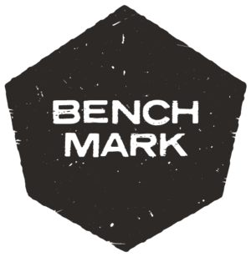
Saturday June 6th, 2020
Venue is the Historic York Barbell Auditorium
3300 Board Rd. York, PA 17406

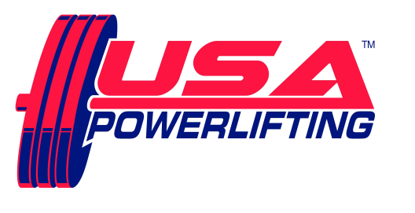

Sanctioned by USA Powerlifting usapowerlifting.com
Sponsored by Nutritional Technologies nt-307.com

THIS EVENT IS CAPPED AT 60 LIFTERS

SCHEDULE: All events take place at YORK BARBELL USA
Friday June 5th 6:00 PM to 7:30 PM - Early equipment check for any lifters, if interested.
Saturday June 6th 7:00 AM to 8:30 AM - Weigh-in / equipment check for morning session.
12:00PM Weigh-in/ Equipment check for PM Session (if necessary)

RULES CLINIC - after weigh-ins, from 8:30 till approximately 8:40 AM.
from 1:00 -1:30 PM for afternoon session
SQUAT contest will start approximately 9:15 AM, PM session starts about 2:00 PM, but depends on turnout!

ENTRY FEE: $80.00 for Raw POWERLIFTING contest
$40.00 for each BENCH and/or DEADLIFT contest entered.
$15.00 for each additional division within each contest.
Fees are not refundable.

USA POWERLIFTING cards not available at the meet.
Please renew online at: http://www.usapowerlifting.com/membership-application

MEET DIRECTOR: Ron Lobb (484) 542-0432 ronaldlobb@gmail.com

RECORDS:
STATE RECORDS CAN BE SET , AMERICAN RECORDS CAN ONLY BE SET IN THE SINGLE LIFT BP/DL CONTESTS
ALL Current USA POWERLIFTING Records are at www.purepowerlifting.com and
USA Powerlifting (USA Powerlifting) Proof of age required for age records.

DEADLINE:
Entries must be submitted no later than May 22, 2020

ELIGIBILITY:
Must be a current USA POWERLIFTING member.
USA POWERLIFTING cards not available at the meet.
Please renew online at: http://www.usapowerlifting.com/membership-application

BANNED SUBSTANCES:
Check www.wada-ama.org for banned substances list.
10% of lifters will be drug tested!

AWARDS:
Medals for Top 3 in each division.
“Best Lifter” awards as appropriate depending on turnout per division.
Team Awards as appropriate – Tentative Roster must be submitted by deadline /
Team entry fee $25 and must be a USA POWERLIFTING registered team.

WEIGHT CLASSES:
Men: 53KG, 59KG, 66KG, 74KG, 83KG, 93KG, 105KG, 120KG, 120+KG
Women: 43KG, 47KG, 52KG, 57KG, 63KG, 72KG, 84KG, 84+KG

DIVISIONS:
Youth: Teen 1 (14-15) Teen 2 (16-17) Teen 3 (18-19)
Junior: 20 - 23
Master: 1a (40-44) 1b (45-49) 2a (50-54) 2b (55-59)
3a (60-64) 3b (65-69) 4a (70-74) 4b (75-79)
Special Olympians with the same weight classes.

ATTIRE:
Raw: Non-supportive one-piece (singlet) lifting suit, 24” wrist wraps, knee sleeves and
4” wide powerlifting belt allowed. (No Velcro)
Equipped: USA POWERLIFTING Single Ply

FORMAT:
Flight system will be used. Weights will be in kilos. Single platform contest planned

FOOD: Breakfast & Lunch available near the venue

