2019 USAPL Pennsylvania State
BENCH and DEADLIFT Championships and Raw National
Powerlifting Qualifier
USAPL Sanction #PA-2019-12
Saturday May 18th, 2019

CROSSFIT Q 18 s 5th St , Quakertown, Pennsylvania 18591

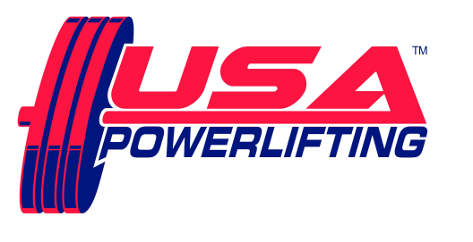

Sanctioned by USA Powerlifting usapowerlifting.com
Sponsored by Nutritional Technologies nt-307.com

THIS EVENT IS CAPPED AT 60 LIFTERS

SCHEDULE: All events take place at CROSSFIT Q
Friday May 17th6:00 PM to 7:30 PM - Early equipment check for any lifters, if interested.
Saturday May 18th7:00 AM to 8:30 AM - Weigh-in / equipment check for morning session.
12pm. Weigh-in/ Equipment check for PM Session (if necessary)

RULES CLINIC - after weigh-ins, from 8:30 till approximately 8:40 AM.
from 1:00 -1:30 PM for afternoon session

SQUAT contest will start approximately 9:15 AM, PM session starts about 2:00 PM, but depends on turnout!

ENTRY FEE: $75.00 for Raw POWERLIFTING contest
$40.00 for each BENCH and/or DEADLIFT contest entered.
$15.00 for each additional division within each contest.
Fees are not refundable.

MEET DIRECTOR: Ron Lobb (484) 542-0432 ronaldlobb@gmail.com

RECORDS:
STATE RECORDS CAN BE SET IN THE 3 LIFT MEET, AMERICAN RECORDS CAN ONLY BE SET IN THE SINGLE LIFT BENCH AND SINGLE LIFT DEADLIFT CONTESTS
ALL Current USAPL Records are at www.purepowerlifting.com and www.adfpa.com
Proof of age required for age records.

ELIGIBILITY:
Must be a current USAPL member. USAPL cards not available at the meet.
Please renew online at: http://www.usapowerlifting.com/membership-application

BANNED SUBSTANCES:
Check www.wada-ama.org for banned substances list.
10% of lifters will be drug tested!

AWARDS:
Medals for Top 3 in each division.
“Best Lifter” awards as appropriate depending on turnout per division.
Team Awards as appropriate – Tentative Roster must be submitted by deadline / Team entry fee $25 and must be a USAPL registered team.

WEIGHT CLASSES:
Men: 53KG, 59KG, 66KG, 74KG, 83KG, 93KG, 105KG, 120KG, 120+KG
Women: 43KG, 47KG, 52KG, 57KG, 63KG, 72KG, 84KG, 84+KG

DIVISIONS:
Open: (Age 14+) Youth: (8-9) (10-11) (12-13)
Teen: (14-15) (16-17) (18-19) Junior: (20 – 23)
Master: (40-44) (45-49) (50-54) (55-59) (60-64)
(65-69) (70-74) (75-79) (80-84) (85-89)
Special Olympians Police/Fire/Military

ATTIRE:
Raw: Non-supportive one-piece (singlet) lifting suit, 24” wrist wraps, knee sleeves and 4” wide powerlifting belt allowed. (No Velcro)
Equipped: USAPL Single Ply

FORMAT: Flight system will be used. Weights will be in kilos. Single platform contest planned

HOTEL ACCOMMODATIONS:

For a discounted room rate, please contact the Holiday Inn Express Hotel and Suites located on Route 663, Quakertown, PA. It is conveniently located near the Quakertown exit, PA Turnpike. When calling to make a reservation, mention the group “USAPL powerlifting”.

Holiday Inn Express Hotel and Suites
1918 John Fries Highway (Route 663)
Quakertown, PA 18951
(215) 529-7979

FOOD:

Breakfast & Lunch available near the venue

