USA Powerlifting 2019
York Barbell Powerlifting
Championships AND Raw National Qualifier

USA Powerlifting Sanction #PA-2019-04
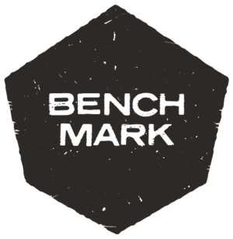
Saturday June 8th, 2019
Venue is the Historic York Barbell Auditorium
3300 Board Rd. York, PA 17406

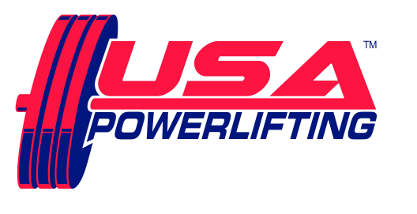

Sanctioned by USA Powerlifting usapowerlifting.com
Sponsored by Nutritional Technologies nt-307.com

THIS EVENT IS CAPPED AT 60 LIFTERS

SCHEDULE: All events take place at YORK BARBELL USA
Friday June 7th6:00 PM to 7:30 PM - Early equipment check for any lifters, if interested.
Saturday June 8th7:00 AM to 8:30 AM - Weigh-in / equipment check for morning session.
12pm. Weigh-in/ Equipment check for PM Session (if necessary)

RULES CLINIC - after weigh-ins, from 8:30 till approximately 8:40 AM.
from 1:00 -1:30 PM for afternoon session
SQUAT contest will start approximately 9:15 AM, PM session starts about 2:00 PM, but depends on turnout!

ENTRY FEE: $80.00 for Raw POWERLIFTING contest
$40.00 for each BENCH and/or DEADLIFT contest entered.
$10.00 for each additional division within each contest.
Fees are not refundable.

USA POWERLIFTING cards not available at the meet.
Please renew online at: http://www.usapowerlifting.com/membership-application

MEET DIRECTOR: Ron Lobb (484) 542-0432 ronaldlobb@gmail.com

RECORDS:
STATE RECORDS CAN BE SET , AMERICAN RECORDS CAN NOT BE SET IN ANY CONTEST
ALL Current USA POWERLIFTING Records are at www.purepowerlifting.com and USA Powerlifting (USA Powerlifting) Proof of age required for age records.

DEADLINE:
Online entries must be received no later than May 25, 2019

ELIGIBILITY:
Must be a current USA POWERLIFTING member.
USA POWERLIFTING cards not available at the meet.
Please renew online at: http://www.usapowerlifting.com/membership-application

BANNED SUBSTANCES:
Check www.wada-ama.org for banned substances list.
10% of lifters will be drug tested!

AWARDS:
Medals for Top 3 in each division.
“Best Lifter” awards as appropriate depending on turnout per division.
Team Awards as appropriate – Tentative Roster must be submitted by deadline / Team entry fee $25 and must be a USA POWERLIFTING registered team.

WEIGHT CLASSES:
Men: 53KG, 59KG, 66KG, 74KG, 83KG, 93KG, 105KG, 120KG, 120+KG
Women: 43KG, 47KG, 52KG, 57KG, 63KG, 72KG, 84KG, 84+KG

DIVISIONS:
Open: (Age 14+) Youth: (8-9) (10-11) (12-13)
Teen: (14-15) (16-17) (18-19) Junior: (20 – 23)
Master: (40-44) (45-49) (50-54) (55-59) (60-64)
(65-69) (70-74) (75-79) (80-84) (85-89)
Special Olympians Police/Fire/Military

ATTIRE:
Raw: Non-supportive one-piece (singlet) lifting suit, 24” wrist wraps, knee sleeves and 4” wide powerlifting belt allowed. (No Velcro)
Equipped: USA POWERLIFTING Single Ply

FORMAT:
Flight system will be used. Weights will be in kilos. Single platform contest planned

FOOD:

Breakfast & Lunch available near the venue

