2016 USAPL Pennsylvania State
BENCH and DEADLIFT Championships and Full Raw Power Meet
USAPL Sanction #PA-2016-01
Saturday May 14th, 2016

East Swamp Church, 2405 E. Swamp Rd., Quakertown, Pennsylvania 18591

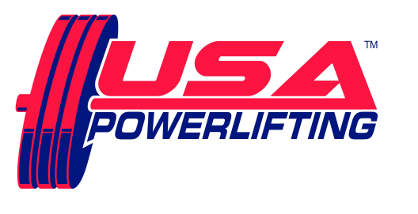

Sanctioned by USA Powerlifting (www.adfpa.com)
Sponsored by Nutritional Technologies (Nutritional Technologies)

THIS EVENT IS CAPPED AT 60 LIFTERS

SCHEDULE: All events take place at East Swamp Church
Friday May 13th6:00 PM to 7:30 PM - Early equipment check for any lifters, if interested.
Saturday May 14th7:00 AM to 8:30 AM - Weigh-in / equipment check for morning session.
12pm. Weigh-in/ Equipment check for PM Session

RULES CLINIC - after weigh-ins, from 8:30 till approximately 8:40 AM.
from 1:00 -1:30 PM for afternoon session

SQUAT contest will start approximately 9:15 AM, PM session starts about 2:00 PM, but depends on turnout!

MEET DIRECTOR: Ron Lobb (484) 542-0432 ronaldlobb@gmail.com

ENTRY FEE: $75.00 for Raw POWERLIFTING contest
$40.00 for each BENCH and/or DEADLIFT contest entered.
$10.00 for each additional division within each contest.
Fees are not refundable.

RECORDS:
USAPL 3 Lift, Single Lift BENCH and DEADLIFT PA State and American Records can be set.
ALL Current USAPL Records are at www.purepowerlifting.com and www.adfpa.com
Proof of age required for age records.

ELIGIBILITY: Must be a current USAPL member.
Limited cards will be available for sale at the meet.
Please renew online at: http://www.usapowerlifting.com/membership-application
No credit cards accepted, cash or check only.

BANNED SUBSTANCES:
Check www.wada-ama.org for banned substances list.
10% of lifters will be drug tested!

AWARDS:
Medals for Top 3 in each division.
“Best Lifter” awards as appropriate depending on turnout per division.
Team Awards as appropriate – Tentative Roster must be submitted by deadline / Team entry fee $25 and must be a USAPL registered team.

WEIGHT CLASSES:
Men: 53KG, 59KG, 66KG, 74KG, 83KG, 93KG, 105KG, 120KG, 120+KG
Women: 43KG, 47KG, 52KG, 57KG, 63KG, 72KG, 84KG, 84+KG

DIVISIONS:
Youth: Teen 1 -14&15, Teen 2 - 16&17, Teen 3 - 18&19
Junior: 20 - 23
Submaster: 35 - 39
Master: 40 - 44, 45 - 49, 50 - 54, 55 - 59, 60 - 64, 65 - 69, 70-74...
Special Olympians with the same weight classes.

ATTIRE:
Raw: Non-supportive one-piece (singlet) lifting suit, 24” wrist wraps, knee sleeves and 4” wide powerlifting belt allowed. (No Velcro)
Equipped: USAPL Single Ply

FORMAT:
Flight system will be used. Weights will be in kilos. Single platform contest planned

HOTEL ACCOMMODATIONS:

For a discounted room rate, please contact the Holiday Inn Express Hotel and Suites located on Route 663, Quakertown, PA. It is conveniently located near the Quakertown exit, PA Turnpike. When calling to make a reservation, mention the group “USAPL powerlifting”.

Holiday Inn Express Hotel and Suites
1918 John Fries Highway (Route 663)
Quakertown, PA 18951
(215) 529-7979

FOOD:

Breakfast & Lunch
will be available for purchase at the event

See what the ladies have got cookin’!

